"Progress towards deep-sea mining - environmental aspects and associated engineering challenges"

Wednesday 4th March 2020 at 18:00

(refreshments available from 17:30)

Institution of Civil Engineers, One Great George Street, Westminster, London SW1P 3AA

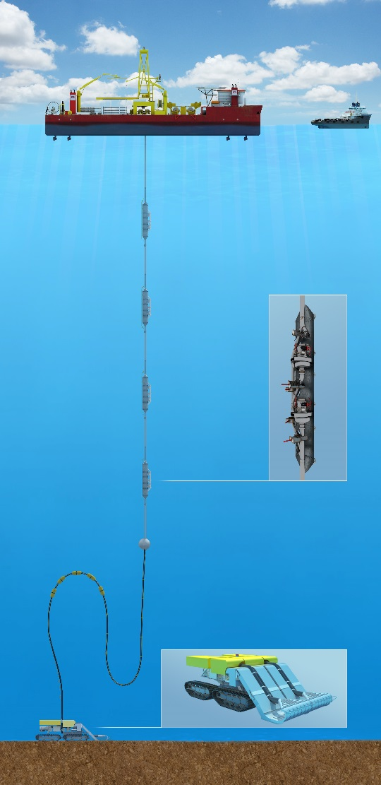
As of January 2020, 30 contracts for exploration for deep-sea minerals have been awarded by the International Seabed Authority (ISA) covering an area close to 1.5 million km² in areas beyond national jurisdiction. So far, no contracts for actual mining have been approved by the ISA but claims may be submitted once the regulations have been approved sometime in 2020 or 2021.There are an unknown number of contracts and licences in national waters. A number of contractors to the ISA and other organisations are actively developing equipment to mine both manganese nodules and polymetallic sulphides.
Manganese nodules are found in the deep ocean basins generally between 4000 and 6000 m water depth where they form a 2-dimensional deposit with the potato sized nodules lying strewn across the seabed. Due to the 2-dimentsional nature of the resource each manganese nodule mine will extend across more than 100 km² per year of operation. Whilst they may be easy to collect from the seabed the collection process will produce plumes of sediment laden water that will impact seabed organisms over a much wider area than that mined. Major engineering challenges include the need to reduce the volume and spread of these plumes and to enhance the potential for recovery of the ecosystem.
Mining for polymetallic sulphides will be analogous to mining on land with 3-dimensional deposits and mines potentially occupying the same location for many years. However these mines are located on ocean ridges and could affect rare groups of organisms such as hydrothermal vent faunas without careful

planning. Again, management or elimination of plumes and their impact could reduce the environmental impact.
There are many engineering challenges to deep-sea mining. This talk will highlight areas where good equipment design could reduce environmental impacts.

Speaker: Professor Phil Weaver - Seascape Consultants Ltd, Romsey, UK
Phil Weaver trained as a geologist and became Director of the NERC Strategic Research Division at the National Oceanography Centre, Southampton in 2006. He left NOC in 2010 to set up Seascape Consultants Ltd, Phil coordinated the EU funded MIDAS project looking at the environmental impacts of deep-sea mining which ended in 2016. He is now a partner in two EC funded projects Blue Nodules and Blue Harvesting that are developing a deep-sea harvesting system for manganese nodules with a reduced environmental footprint. He also coordinates a project to assist the ISA in developing a Regional environmental Management Plan for polymetallic sulphides in the North Atlantic Ocean.

Booking link: https://www.ice.org.uk/events/progress-towards-deep-sea-mining-london

OES Members, please note if you wish to watch online you do not need to book online. A link will be sent to all OES members ahead of the event

